1.Display your systems IP Address, Subnet mask using ipconfig, and find out the network address and the maximum number of systems possible on your network and range of IP addresses available to these systems.

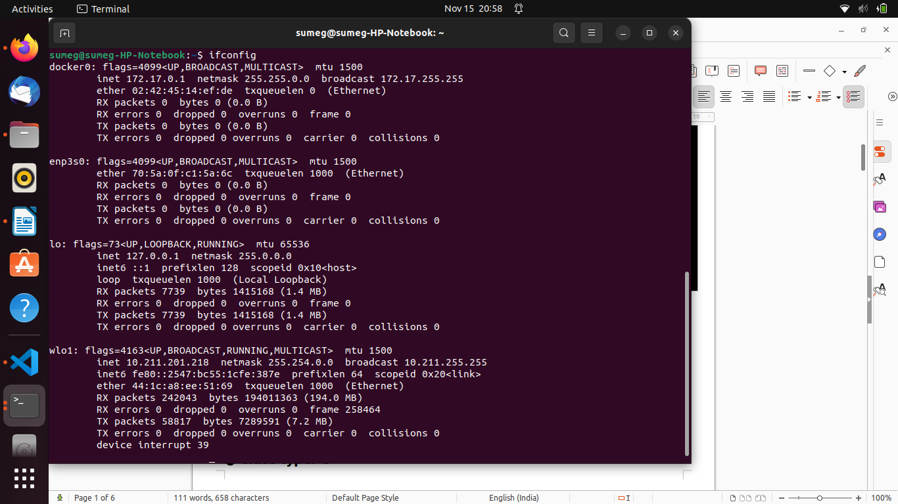

**● System IP Address: 172.17.0.1**

**● Subnet mask: 255.255.0.0**

**● Network ID: 192.168.43.0**

**● Broadcast ID: 172.17.255.255**

**● Maximum number of system possible on the network: 254**

**● Range of IP addresses: 192.168.43.0 to 192.168.43.255**

**● Class type: B**

2.With help of ping, check if you are connected to other systems of your network and find the route to connect to that system using tracert. List all the processes which are using ports for TCP protocol.

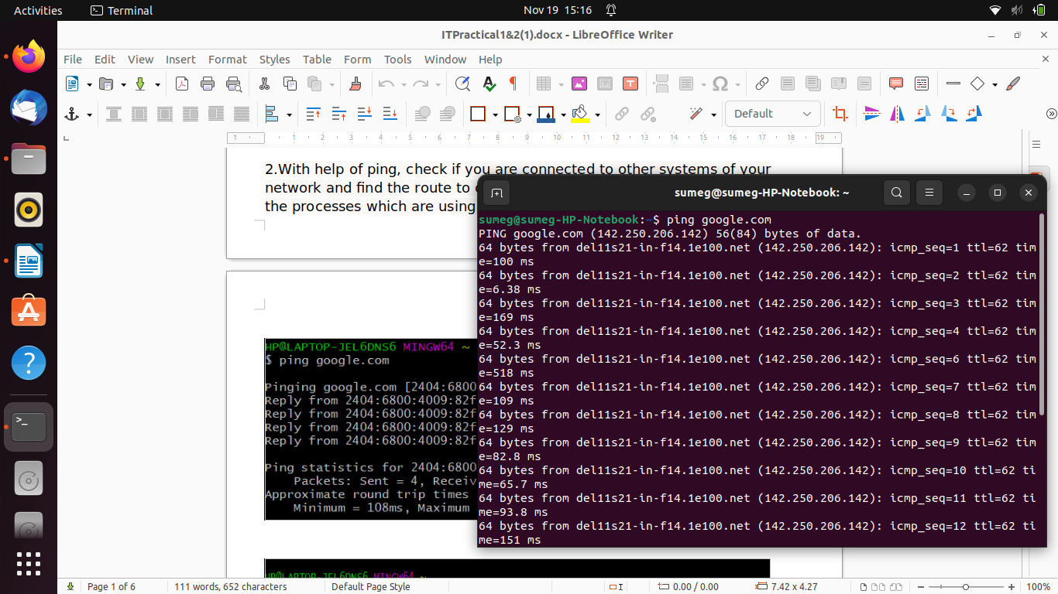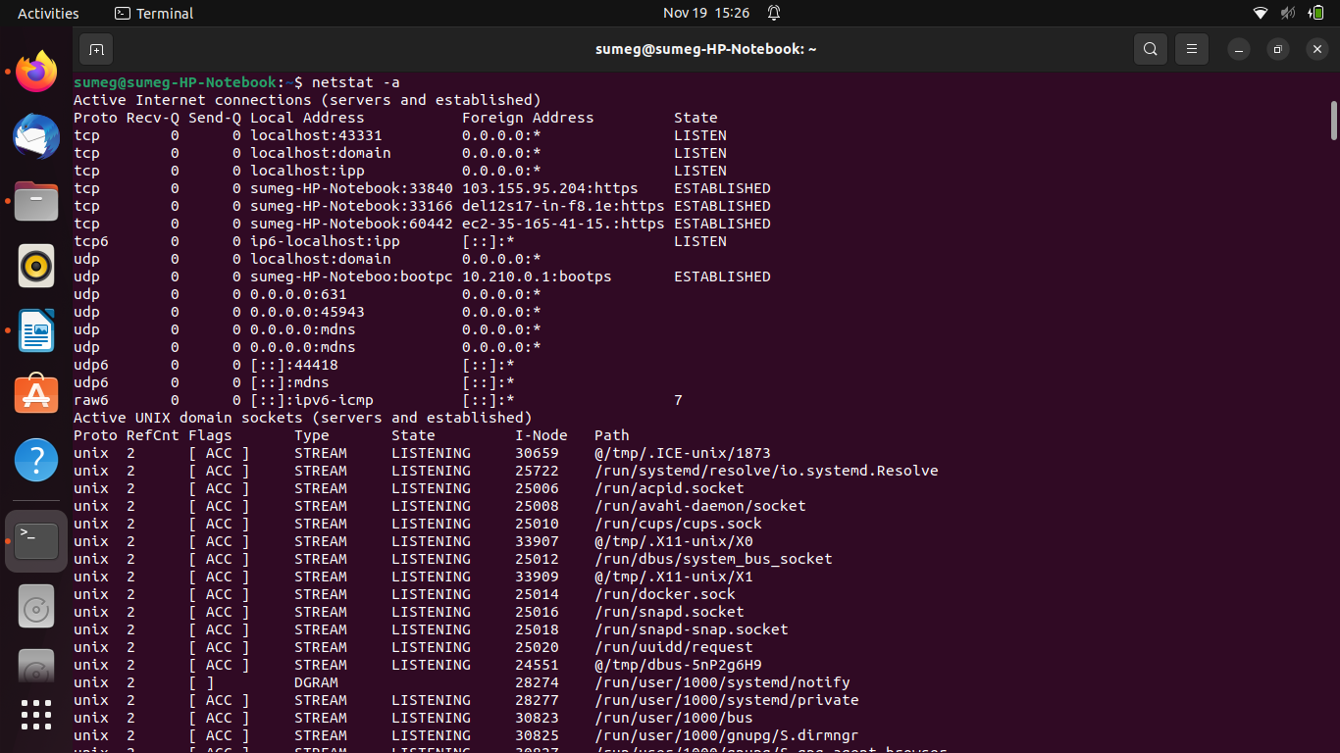

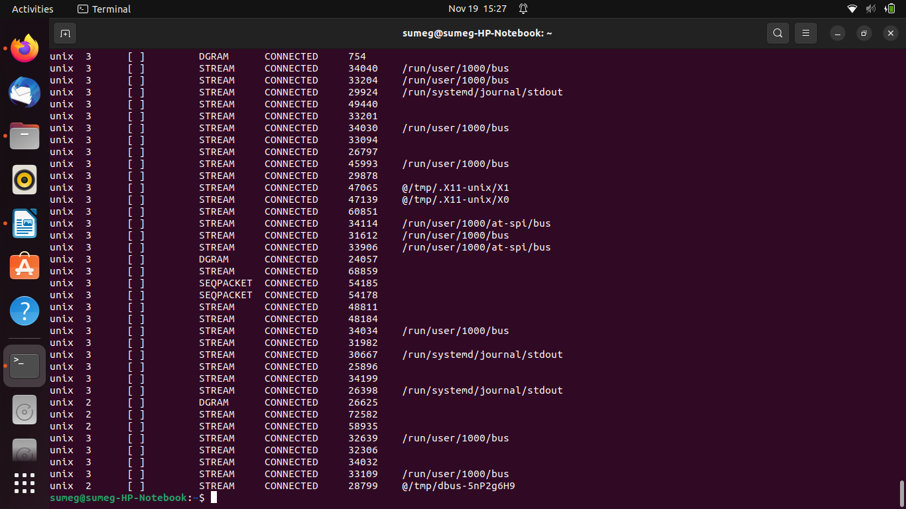

Practical 3:

html:

<!doctype html css png>

<html lang="en">

<head>

<!-- Required meta tags -->

<meta charset="utf-8">

<meta name="viewport" content="width=device-width, initial-scale=1">

<link rel="stylesheet" href="https://cdnjs.cloudflare.com/ajax/libs/font-awesome/6.0.0/css/all.min.css" integrity="sha512-9usAa10IRO0HhonpyAIVpjrylPvoDwiPUiKdWk5t3PyolY1cOd4DSE0Ga+ri4AuTroPR5aQvXU9xC6qOPnzFeg==" crossorigin="anonymous" referrerpolicy="no-referrer" />

<!-- Bootstrap CSS -->

<link href="https://cdn.jsdelivr.net/npm/bootstrap@5.0.2/dist/css/bootstrap.min.css" rel="stylesheet" integrity="sha384-EVSTQN3/azprG1Anm3QDgpJLIm9Nao0Yz1ztcQTwFspd3yD65VohhpuuCOmLASjC" crossorigin="anonymous">

<style>

@import url('https://fonts.googleapis.com/css2?family=Nunito+Sans:ital,wght@0,300;1,600&display=swap');

</style>

<link rel="stylesheet" href="./scss/main.css">

<title>About Me</title>

</head>

<body>

<div class="main_header">

<nav class="navbar navbar-expand-lg ">

<div class="container">

<a class="navbar-brand" href="#">CodeNet

<div class="logo2"><i class="fa-solid fa-paper-plane"></i></div>

</a>

<button class="navbar-toggler" type="button" data-bs-toggle="collapse" data-bs-target="#navbarSupportedContent" aria-controls="navbarSupportedContent" aria-expanded="false" aria-label="Toggle navigation">

<span class="navbar-toggler-icon"></span>

</button>

<div class="collapse navbar-collapse" id="navbarSupportedContent">

<ul class="navbar-nav me-auto mb-2 mb-lg-0">

<li class="nav-item">

<a class="nav-link active" aria-current="page" href="#">Home</a>

</li>

<li class="nav-item">

<a class="nav-link" href="#">About</a>

</li>

<li class="nav-item">

<a class="nav-link" href="#">Gallery</a>

</li>

<li class="nav-item">

<a class="nav-link" href="#">Contact</a>

</li>

<li class="nav-item">

<a class="nav-link" href="#">Views</a>

</li>

</ul>

<form class="d-flex">

<button class="btn btn-outline-success" type="submit">SignIn</button>

</form>

</div>

</div>

</nav>

</div>

<!--My header part-->

<div class="header_hero">

<div class="container">

<div class="row">

<div class="col-lg-6 col-10 mx-auto">

<div class="header_hero_text">

<div class="aboutme"><h2><span>About Me</span></h2>

<div class="college">

<div class="heading"><p></p></div>

<div class="info">

<p>

Hey folks,

I'm persuing Bachelor of Computer Science from Delhi Universtiy,currently I'm in my third year and current working to enhance my skill with various coding language that I've showcased here. There are projects that I'm working on and learnig various technologies based on these languages.

<br>

To sharpen my commpetitive coding there is a renowed platform <a href="http://">codecheff</a> there I participate in weekly competetions.

The following games are the projeacts that I worked on hope you will check them out too .

</p>

</div>

</div>

</div>

<div class="header_text_btn">

<a href="#" alt="">Game 1</a>

<a href="#" alt="" id="btn__2">Game 2</a>

</div>

</div>

</div>

<!-- right side images -->

<div class="col-lg-6 col-10 mx-auto">

<figure class="header_hero__img" >

<div class="lang">

<div class="language"><p>Programming languages</p></div>

<div></div>

<div class="pack">

<div><p> </p></div>

<div class="html"><img src="images/html-removebg-preview.png" alt=""></div>

<div><p> </p></div>

</div>

<div class="pack">

<div class="css"><img src="images/css-removebg-preview.png" alt=""></div>

<div><p> </p></div>

<div class="nodejs"><img src="images/nodejs.png" alt=""></div>

</div>

<div class="pack">

<div class="js"><img src="images/js-removebg-preview.png" alt=""></div>

<div class="mongodb"><img src="images/mongodb-removebg-preview.png" alt=""></div>

<div class="c"><img src="images/c++-removebg-preview.png" alt=""></div>

</div>

<div class="pack">

<div class="java"><img src="images/java-removebg-preview.png" alt=""></div>

<div class="docker"><img src="images/docker-removebg-preview.png" alt=""></div>

<div class="mysql"><img src="images/mysql-removebg-preview.png" alt=""></div>

</div>

<div class="pack">

<div><p> </p></div>

<div class="git"><img src="images/git-removebg-preview.png" alt=""></div>

<div class="python"><img src="images/python-removebg-preview.png" alt=""></div>

</div>

</div>

</div>

</figure>

</div>

<!-- Education info -->

<div class="container1">

<div class="heading"><h2><span>Education</span></h2></div>

<div class="row1">

<div class="column1">

<div class="edu">

<div class="grad">

<div class="heading"><h3><span>Graduation</span></h3></div>

<div class="info">

<p>

I'm student persuing Bachelor of Computer Science Honour form Ramanujan college Delhi University.

<br>

It's my third year of graduation.

There are many subjects in my course that laid out a path for me to explore new genre that includes

</p>

<div class="list">

<ul class="subjects">

<div class="block1">

<ol class="sub1">C++</ol>

<ol class="sub1">Java</ol>

<ol class="sub1">Python</ol>

</div>

<div class="block2">

<ol class="sub1">Web Devlopment</ol>

<ol class="sub1">CSA</ol>

<ol class="sub1">OS</ol>

</div>

</ul>

</div>

<p>

and many other subjects.

This profile is also one of the project that I'm working on.

</p>

</div>

</div>

</div>

</div>

<div class="column2">

<div class="edu">

<div class="heading">

<div class="school">

<div class="heading"><h3><span>High School</span></h3></div>

<div class="info">

<p>

I completed my high school graduation from Vishwa Bharti Public School in Greater Noida.

Comming from a science background and having python in 11th and 12th made me zealous to persue my carrer in field of computer science.

</p>

<section class="hobbies-section">

<h1>My Hobbies</h1>

<p>I love listening to music, watching anime and reading manga.</p>

</section>

</div>

</div>

</div>

</div>

</div>

</div>

</div>

</div>

</div>

</div>

<div class="footer">

<div class="contain">

<div class="column">

<div class="row1">

<p>

<img src="images/IMG20220911133511 .jpg" alt="">

</p>

</div>

<div class="row2">

<div class="navi">

<ul class="nav_item">

<li class="navi-item">

<a href="http://">Github</a>

</li>

<li class="navi-item">

<a href="http://">Linkdin</a>

</li>

<li class="navi-item">

<a href="http://">Instagram</a>

</li>

<li class="navi-item">

<a href="http://">Twitter</a>

</li>

<li class="navi-item"

><a href="http://">Facebook</a>

</li>

</ul>

</div>

</div>

</div>

</div>

</div>

<!--My header part ends-->

<!-- Optional JavaScript; choose one of the two! -->

<!-- Option 1: Bootstrap Bundle with Popper -->

<script src="https://cdn.jsdelivr.net/npm/bootstrap@5.0.2/dist/js/bootstrap.bundle.min.js" integrity="sha384-MrcW6ZMFYlzcLA8Nl+NtUVF0sA7MsXsP1UyJoMp4YLEuNSfAP+JcXn/tWtIaxVXM" crossorigin="anonymous"></script>

<!-- Option 2: Separate Popper and Bootstrap JS -->

<!--

<script src="https://cdn.jsdelivr.net/npm/@popperjs/core@2.9.2/dist/umd/popper.min.js" integrity="sha384-IQsoLXl5PILFhosVNubq5LC7Qb9DXgDA9i+tQ8Zj3iwWAwPtgFTxbJ8NT4GN1R8p" crossorigin="anonymous"></script>

<script src="https://cdn.jsdelivr.net/npm/bootstrap@5.0.2/dist/js/bootstrap.min.js" integrity="sha384-cVKIPhGWiC2Al4u+LWgxfKTRIcfu0JTxR+EQDz/bgldoEyl4H0zUF0QKbrJ0EcQF" crossorigin="anonymous"></script>

-->

</body>

</html>

css:

@import url("https://fonts.googleapis.com/css2?family=Nunito+Sans:ital,wght@0,300;1,600&display=swap");

html {

font-size: 62.5%;

}

body {

font-family: "Nunito Sans", sans-serif;

font-weight: 300;

}

a, a:hover {

text-decoration: none;

}

.main_header {

width: 100%;

line-height: 10rem;

background: linear-gradient(rgba(0, 0, 0, 0.5), rgba(0, 0, 0, 0.5)) #0a183d;

}

.main_header .logo1{

color: #fff;

display: flex;

flex-direction: row;

}

.main_header a{

color: #fff;

font-size: x-large;

}

.logo1 .name{

display: flex;

flex-direction: column;

}

.main_header .logo2 {

color: #fff;

-webkit-animation: music 4s linear infinite alternate;

animation: music 4s linear infinite;

animation-direction: alternate;

position: relative;

}

.main_header .navbar-brand .fa-solid {

font-size: 2rem;

}

@-webkit-keyframes music {

0% {left:0px; top:0px;}

25% {left:400px; top:0px;}

50% {left:800px; top:0px;}

75% {left:400px; top:0px;}

100% {left:0px; top:0px;}

}

@keyframes music {

0% {left:0px; top:0px;}

25% {left:250px; top:0px;}

50% {left:500px; top:0px;}

75% {left:250px; top:0px;}

100% {left:0px; top:0px;}

}

.main_header .navbar-brand:hover {

filter: drop-shadow(0 1.5rem 1rem rgba(255, 255, 255, 0.5));

}

.main_header:hover {

filter: drop-shadow(0 1.5rem 1rem rgba(0, 0, 0, 0.5));

}

.main_header .navbar-nav {

padding-left: 5rem;

}

.main_header .navbar-nav .nav-item .nav-link {

font-size: 1.6rem;

color: #fff;

text-transform: uppercase;

padding-right: 1rem;

}

.main_header .navbar-nav .nav-item:last-child > a {

padding-right: 0%;

}

.main_header .nav-item:hover > .navlink, .main_header .navbar-brand:hover, .main_header .navbar-brand:hover > .fa-solid {

color: #b71540;

}

.main_header .btn {

padding: 0.8rem 3.2rem;

background: #b71540;

line-height: 3rem;

font-size: 1.8rem;

font-weight: bold;

text-transform: capitalize;

color: #fff;

border: none;

box-shadow: 0rem 8rem 15rem rgba(0, 0, 0, 0.1);

transition: all 0.3s ease 0s;

cursor: pointer;

border-radius: 4.5rem;

outline: none;

}

.main_header .btn:hover {

background-color: #fff;

box-shadow: 0rem 15rem 20rem rgba(255, 255, 157, 0.4);

color: #0a183d;

transform: translateY(-0.7px);

}

.header_hero {

width: 100%;

height: 180vh;

padding: 0 1rem;

background: #0a183d;

}

.header_hero_text {

height: 80vh;

display: flex;

justify-content: center;

align-items: flex-start;

flex-direction: column;

}

.header_hero h2 {

color: #fff;

font-size: 6rem;

margin-bottom: 2rem;

line-height: 150%;

font-weight: 600;

}

.header_hero h3{

color: #fff;

font-size: 4rem;

margin-bottom: 2rem;

line-height: 150%;

font-weight: 600;

}

.header_hero h2 span {

color: #b71540;

text-transform: capitalize;

}

.header_hero .college .heading p{

font-size: 3rem;

color: #fff;

margin-bottom: 2rem;

}

.header_hero p {

font-size: 1.8rem;

color: #fff;

margin-bottom: 2rem;

}

.header_hero .hobbies-section h1{

font-size: 3rem;

color: #fff;

margin-bottom: 2rem;

}

.header_hero .college .info a{

color: #b71540;

text-transform: capitalize;

text-decoration: underline;

}

.header_hero .list .subjects{

display: flex;

flex-direction: row;

}

.header_hero .list ul{

padding: 0px;

}

.header_hero .list ol {

font-size: 1.8rem;

color: #fff;

margin-bottom: 0rem;

}

.header_hero .header_text_btn {

display: flex;

justify-content: center;

align-items: center;

flex-direction: row;

}

.header_hero .header_text_btn a {

padding: 0.8rem 3.2rem;

background: #b71540;

line-height: 3rem;

font-size: 1.8rem;

font-weight: bold;

text-transform: capitalize;

color: #fff;

border: none;

box-shadow: 0rem 8rem 15rem rgba(0, 0, 0, 0.1);

transition: all 0.3s ease 0s;

cursor: pointer;

border-radius: 4.5rem;

outline: none;

}

.header_hero .header_text_btn a:hover {

background-color: #fff;

box-shadow: 0rem 15rem 20rem rgba(255, 255, 157, 0.4);

color: #0a183d;

transform: translateY(-0.7px);

}

.header_hero .header_text_btn #btn__2 {

margin-left: 2rem;

background-color: rgba(255, 255, 255, 0.5);

}

.header_hero .header_text_btn #btn__2:hover {

background-color: #fff;

box-shadow: 0rem 15rem 20rem rgba(255, 255, 157, 0.4);

color: #0a183d;

transform: translateY(-0.7px);

}

.header_hero__img {

height: 70vh;

display: flex;

justify-content: center;

align-items:center;

flex-direction: row;

-webkit-animation: anime-hero 10s linear infinite alternate;

animation: anime-hero 10s linear infinite alternate;

}

@-webkit-keyframes anime-hero {

from {

transform: scale(0.9);

}

to {

transform: scale(1);

}

}

@keyframes anime-hero {

from {

transform: scale(0.9);

}

to {

transform: scale(1);

}

}

.header_hero img {

height:70px;

padding: 0 4rem;

filter: drop-shadow(0 1.5rem 1rem rgba(0, 0, 0, 0.5));

}

.header_hero .lang{

display: flex;

flex-direction: column;

justify-content: center;

align-items: center;

align-self: center;

}

.language p{

font-size:xx-large;

font-weight: 800;

text-decoration: underline;

padding-bottom: 10rem;

filter: drop-shadow(0 1.5rem 1rem rgba(150, 147, 147, 0.5));

}

.header_hero .pack{

display: flex;

flex-direction: row;

justify-content: center;

align-items: center;

align-self: center;

}

.header_hero .html{

position: absolute;

top:50vh;

animation: circle1 5s linear infinite;

}

.header_hero .css{

position: absolute;

top:50vh;

animation: circle2 5s linear 0.5s infinite;

}

.header_hero .nodejs{

position: absolute;

top:50vh;

animation: circle2 5s linear 2s infinite;

}

.header_hero .js{

position: absolute;

top:50vh;

animation: circle2 5s linear 1.5s infinite;

}

.header_hero .mongodb{

position: absolute;

top:50vh;

}

.header_hero .c{

position: absolute;

top:50vh;

animation: circle1 5s linear 1s infinite;

}

.header_hero .docker{

position: absolute;

top:50vh;

animation: circle2 5s linear 2.5s infinite;

}

.header_hero .nodejs{

position: absolute;

top:50vh;

animation: circle1 5s linear 2s infinite;

}

.header_hero .java{

position: absolute;

top:50vh;

animation: circle2 5s linear 3.5s infinite;

}

.header_hero .mysql{

position: absolute;

top:50vh;

animation: circle1 5s linear 4s infinite;

}

.header_hero .git{

position: absolute;

top:50vh;

animation: circle2 5s linear 4.5s infinite;

}

.header_hero .python{

position: absolute;

top:50vh;

animation: circle1 5s linear 3s infinite;

}

@keyframes circle1{

0%{

transform:rotate(0deg)

translate(165px)

rotate(0deg);

}

100%{

transform:rotate(360deg)

translate(165px)

rotate(-360deg);

}

}

@keyframes circle2{

0%{

transform:rotate(0deg)

translate(110px)

rotate(0deg);

}

100%{

transform:rotate(360deg)

translate(110px)

rotate(-360deg);

}

}

.header_hero .container1 .row1{

display: flex;

flex-direction: row;

}

.header_hero .container1 .column1{

padding: 0px 2rem;

}

.header_hero .container1 .column2{

flex: 0 0 auto ;

padding: 0px 2rem;

width:50%;

}

.footer {

display: flex;

justify-content: center;

align-items: center;

flex-direction: row;

background-color: black;

width: 100%;

line-height: 2rem;

background: linear-gradient(rgba(0, 0, 0, 0.5), rgba(0, 0, 0, 0.5)) #0a183d;

}

.footer .column .row1{

display: flex;

flex-direction: column;

justify-content: center;

}

.footer .row1 p{

line-height: 6rem;

margin-top: 2rem;

text-align: center;

}

.footer .row1 img{

height: 35rem;

width:35rem;

border-radius: 50%;

border: solid white;

}

.column .row2 .navi-item{

height: 5vh;

display: flex;

justify-content: center;

align-items: flex-start;

flex-direction: row;

}

.footer .contain .row2 .navi {

padding-left: 5rem;

}

.footer a{

padding: 0.8rem 3.2rem;

line-height: 3rem;

font-size: 1.8rem;

font-weight: bold;

text-transform: capitalize;

color: #fff;

border: none;

box-shadow: 0rem 8rem 15rem rgba(0, 0, 0, 0.1);

transition: all 0.3s ease 0s;

cursor: pointer;

border-radius: 4.5rem;

outline: none;

}

.footer a:hover {

color: #b71540;

transform: translateY(-0.7px);

filter: drop-shadow(0 1.5rem 1rem rgba(253, 253, 253, 0.5));

}

.footer .contain .nav_item:last-child > a {

padding-right: 0%;

}

.footer .contain .row2 .navi .nav_item{

display: flex;

flex-direction: row;

}

@media (max-width: 768px) {

html {

font-size: 55%;

}

.main_header {

line-height: 5rem;

text-align: center;

padding: 0 2rem;

}

.main_header .navbar-nav {

padding-left: 0%;

}

.main_header .navbar .navbar-toggler {

border-color: rgba(255, 255, 255, 0.5);

}

.header_hero .header_hero_text {

text-align: center;

}

.header_hero .header_text_btn {

display: block;

margin: 0 auto;

}

.header_hero .header_text_btn a {

display: block;

text-align: center;

}

.header_hero .header_text_btn #btn__2 {

margin-top: 2rem;

margin-left: 0%;

}

.header_hero__img {

display: none;

}

}/*# sourceMappingURL=main.css.map */

Output:

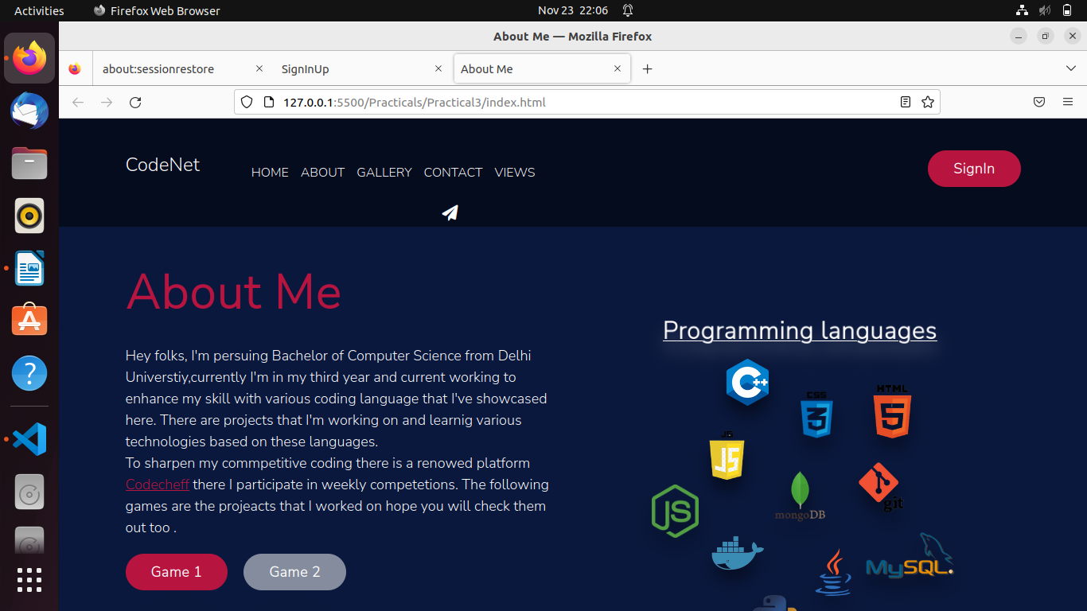

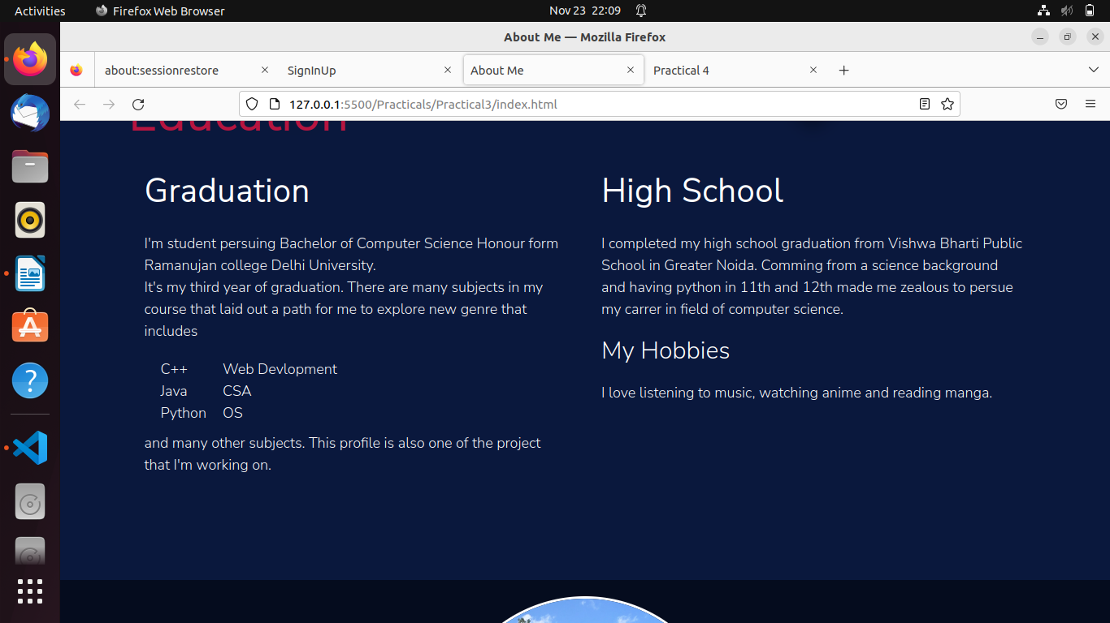

Practical 4:

html:

<!DOCTYPE html>

<html>

<head>

<title>Practical 4</title>

<meta charset="utf-8">

<style type="text/css">

table{

border: 1px solid black;

border-collapse: collapse;

width: 80%;

margin: auto;

}

td,th{

border: 1px solid black;

padding: 5px;

}

.center{

text-align: center;

}

</style>

</head>

<body>

<h1>Printing Table from 2 to 10</h1>

<table class="center" id="content">

</table>

<script type="text/javascript">

function getRandomColor() {

var letters = '0123456789ABCDEF';

var color = '#';

for (var i = 0; i < 6; i++) {

color += letters[Math.floor(Math.random() * 16)];

}

return color;

}

var tbl = document.getElementById('content');

var num= 2;

var abc = setInterval(printrow,5000);

function printrow(){

if (num== 10)

{

clearInterval(abc);

}

var res = "";

for(var i = 1; i<= 10; i++){

res = res+ "<td>"+ num + "*" + i + "=" + num * i+"</td>";

}

num++;

var row = document.createElement('tr');

row.style.color= getRandomColor();

row.style.fontSize = (num+10)+"px";

row.innerHTML=res;

tbl.append(row);

}

</script>

</body>

</html>

Output:

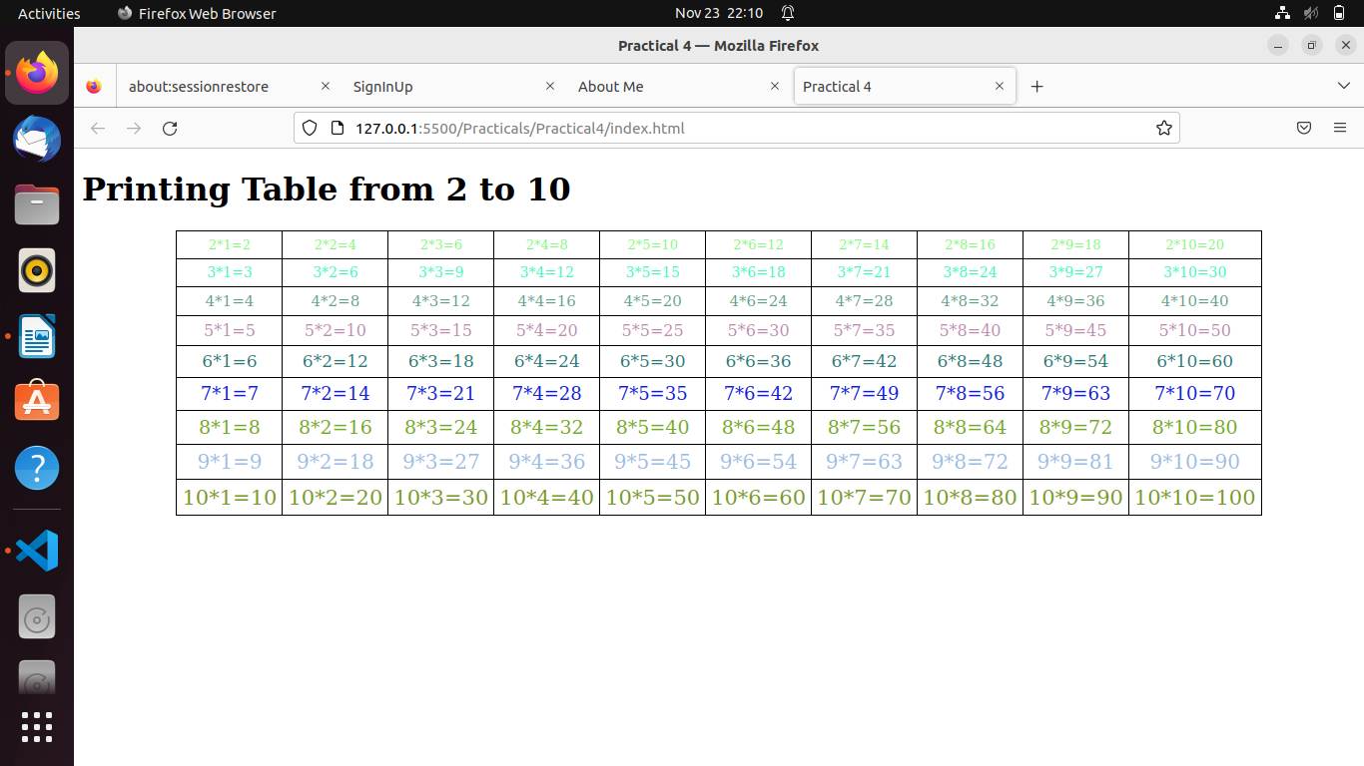

Practical 5:

html:

<!DOCTYPE html>

<html lang="en">

<head>

<meta charset="UTF-8" />

<meta http-equiv="X-UA-Compatible" content="IE=edge" />

<meta name="viewport" content="width=device-width, initial-scale=1.0" />

<title>Style Paragraph</title>

<link rel="stylesheet" href="style.css" />

<script defer src="script.js"></script>

</head>

<body>

<h1>Click the buttons below to style the paragraph.</h1>

<p class="para">

Lorem ipsum dolor sit amet consectetur adipisicing elit. Sit eos mollitia

expedita sint quidem id, ut hic eum, asperiores amet quaerat autem quasi

unde sequi molestias itaque atque explicabo assumenda! Lorem ipsum dolor

sit, amet consectetur adipisicing elit. Velit sed, et eum enim a odit

ullam quo in nesciunt consequatur reiciendis tempora minima quasi laborum,

recusandae laudantium, consectetur libero mollitia. Lorem ipsum dolor sit,

amet consectetur adipisicing elit. Commodi magnam quas aperiam fuga illum,

molestias adipisci deserunt voluptatibus doloribus aliquid. Illo quia sit

necessitatibus deleniti saepe possimus cum perferendis earum?

</p>

<div class="container">

<button class="el el--1">Red</button>

<button class="el el--2">Green</button>

<button class="el el--3">Blue</button>

<button class="el el--4">10</button>

<button class="el el--5">20</button>

<button class="el el--6">30</button>

<button class="el el--7">Sans-serif</button>

<button class="el el--8">Cursive</button>

<button class="el el--9">Monospace</button>

</div>

</body>

</html>

script:

const btnRed = document.querySelector(".el--1");

btnRed.addEventListener("click", function () {

var textEl = document.querySelector(".para");

console.log(textEl.textContent);

if (textEl.classList.contains("green-text")) {

textEl.classList.remove("green-text");

}

if (textEl.classList.contains("blue-text")) {

textEl.classList.remove("blue-text");

}

textEl.classList.add("red-text");

});

const btnGreen = document.querySelector(".el--2");

btnGreen.addEventListener("click", function () {

var textEl = document.querySelector(".para");

console.log(textEl.textContent);

if (textEl.classList.contains("red-text")) {

textEl.classList.remove("red-text");

}

if (textEl.classList.contains("blue-text")) {

textEl.classList.remove("blue-text");

}

textEl.classList.add("green-text");

});

const btnBlue = document.querySelector(".el--3");

btnBlue.addEventListener("click", function () {

var textEl = document.querySelector(".para");

console.log(textEl.textContent);

if (textEl.classList.contains("red-text")) {

textEl.classList.remove("red-text");

}

if (textEl.classList.contains("green-text")) {

textEl.classList.remove("green-text");

}

textEl.classList.add("blue-text");

});

const btn10 = document.querySelector(".el--4");

btn10.addEventListener("click", function () {

var textEl = document.querySelector(".para");

console.log(textEl.textContent);

if (textEl.classList.contains("mid-text")) {

textEl.classList.remove("mid-text");

}

if (textEl.classList.contains("large-text")) {

textEl.classList.remove("large-text");

}

textEl.classList.add("small-text");

});

const btn20 = document.querySelector(".el--5");

btn20.addEventListener("click", function () {

var textEl = document.querySelector(".para");

console.log(textEl.textContent);

if (textEl.classList.contains("small-text")) {

textEl.classList.remove("small-text");

}

if (textEl.classList.contains("large-text")) {

textEl.classList.remove("large-text");

}

textEl.classList.add("mid-text");

});

const btn30 = document.querySelector(".el--6");

btn30.addEventListener("click", function () {

var textEl = document.querySelector(".para");

console.log(textEl.textContent);

if (textEl.classList.contains("small-text")) {

textEl.classList.remove("small-text");

}

if (textEl.classList.contains("mid-text")) {

textEl.classList.remove("mid-text");

}

textEl.classList.add("large-text");

});

const btnSans = document.querySelector(".el--7");

btnSans.addEventListener("click", function () {

var textEl = document.querySelector(".para");

console.log(textEl.textContent);

if (textEl.classList.contains("cursive-text")) {

textEl.classList.remove("cursive-text");

}

if (textEl.classList.contains("monospace-text")) {

textEl.classList.remove("monospace-text");

}

textEl.classList.add("sans-serif-text");

});

const btnCursive = document.querySelector(".el--8");

btnCursive.addEventListener("click", function () {

var textEl = document.querySelector(".para");

console.log(textEl.textContent);

if (textEl.classList.contains("sans-serif-text")) {

textEl.classList.remove("snas-serif-text");

}

if (textEl.classList.contains("monospace-text")) {

textEl.classList.remove("monospace-text");

}

textEl.classList.add("cursive-text");

});

const btnMonospace = document.querySelector(".el--9");

btnMonospace.addEventListener("click", function () {

var textEl = document.querySelector(".para");

console.log(textEl.textContent);

if (textEl.classList.contains("sans-serif-text")) {

textEl.classList.remove("sans-serif-text");

}

if (textEl.classList.contains("cursive-text")) {

textEl.classList.remove("cursive-text");

}

textEl.classList.add("monospace-text");

});

css:

* {

margin: 0;

padding: 0;

box-sizing: border-box;

}

html {

font-size: 62.5%;

}

body {

background-color: #f7f7f7;

width: 120rem;

margin: 0 auto;

}

h1 {

font-family: sans-serif;

font-weight: normal;

color: rgb(116, 29, 61);

font-size: 28px;

width: 780px;

font-weight: bold;

margin: 4rem auto;

text-align: center;

}

.para {

border: 3px solid #304a58;

padding: 2rem;

font-size: 18px;

margin: 4rem auto;

font-family: serif;

}

.container {

display: grid;

grid-template-columns: 1fr 1fr 1fr;

gap: 2rem;

padding: 4rem 5rem;

}

.el {

cursor: pointer;

font-family: sans-serif;

padding: 1.6rem 3.2rem;

text-transform: uppercase;

font-weight: bold;

background-color: rgb(136, 131, 131);

filter: drop-shadow(0rem 0.2rem 0.5rem rgb(0,0,0.2));

color: #f7f7f7;

border: none;

transition: all 0.4s;

font-size: 1.8rem;

}

.el:focus {

box-shadow: 0 0 0 0.8rem rgba(194, 199, 204, 0.877);

}

.el--1:hover {

background-color: #ec5858;

color: #ff0000;

}

.el--2:hover {

background-color: #58bb6a;

color: #02af21;

}

.el--3:hover {

background-color: #4191d8;

color: #0257a1;

}

.el--4:hover {

background-color: #222;

font-size: 1rem;

}

.el--5:hover {

background-color: #222;

font-size: 2rem;

}

.el--6:hover {

background-color: #222;

font-size: 3rem

}

.el--7:hover {

background-color: #223;

font-family: sans-serif;

}

.el--8:hover {

background-color: #222;

font-family:cursive;

}

.el--9:hover {

background-color: #222;

font-family:monospace;

}

.red-text {

color: #f03e3e;

}

.green-text {

color: #37b24d;

}

.blue-text {

color: #1c7ed6;

}

.small-text {

font-size: 1rem;

}

.mid-text {

font-size: 2rem;

}

.large-text {

font-size: 3rem;

}

.sans-serif-text {

font-family: sans-serif;

}

.cursive-text {

font-family:cursive;

}

.monospace-text {

font-family: monospace;

}

Output:

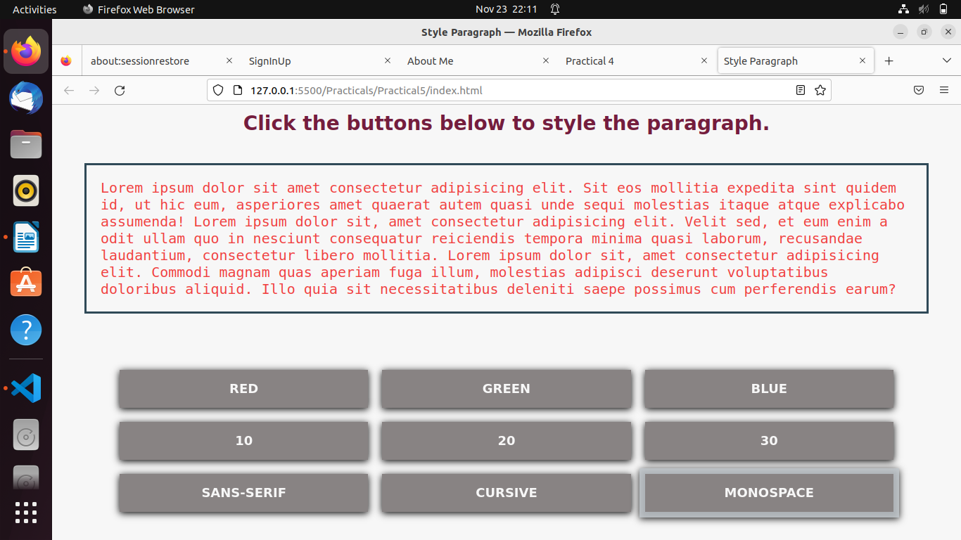

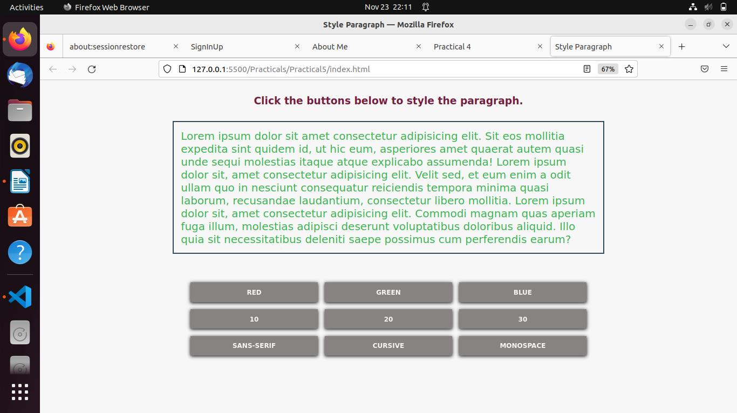

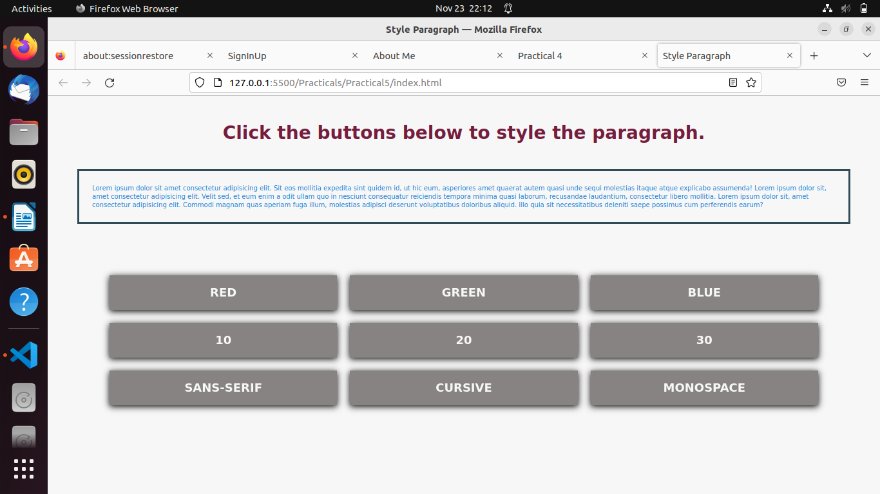

Practical 6:

html:

<!DOCTYPE html>

<html lang="en">

<head>

<meta charset="UTF-8">

<meta http-equiv="X-UA-Compatible" content="IE=edge">

<meta name="viewport" content="width=device-width, initial-scale=1.0">

<title>PetDog</title>

<link rel="stylesheet" href="style.css">

<link rel="stylesheet" href="https://cdnjs.cloudflare.com/ajax/libs/font-awesome/5.15.4/css/all.min.css"

integrity="sha512-1ycn6IcaQQ40/MKBW2W4Rhis/DbILU74C1vSrLJxCq57o941Ym01SwNsOMqvEBFlcgUa6xLiPY/NS5R+E6ztJQ=="

crossorigin="anonymous" referrerpolicy="no-referrer" />

</head>

<body>

<main class="container">

<div class="left-container">

<h1>Pet Survey</h1>

<p><img src="images/pets-dogs.jpg" alt="image not found" ></p>

</div>

<div class="right-container">

<h1>info of your pet</h1>

<header>

<form id="PetForm">

<div class="field">

<label for="name">Name</label>

<input type="text" name="name" id="name" placeholder="Enter your pet's name" required />

</div>

<div class="field">

<label for="age">Age</label>

<input type="number" name="age" id="age" placeholder="Enter your pet's age" required />

</div>

<div class="field">

<label for="weight">Weight</label>

<input type="number" step="0.01"name="weight" id="weight" placeholder="Enter your pet's weight">

</div>

<div class="field">

<label for="type">Type</label>

<select name="type" id="type" required>

<option value="" disabled selected>Select animal specie</option>

<option value="dog">Dog</option>

<option value="cat">Cat</option>

<option value="rabbit">Rabbit</option>

<option value="bird">Bird</option>

<option value="other">Other</option>

</select>

</div>

</header>

<footer>

<input type="submit" value="Submit" />

<input type="reset" value="Reset" />

</footer>

</form>

</div>

</main>

<script>

document.getElementById('PetForm').addEventListener('submit', (e) => {

e.preventDefault();

const name = document.getElementById('name').value;

const age = parseInt(document.getElementById('age').value);

const weight = parseFloat(document.getElementById('weight').value);

const type = document.getElementById('type').value;

const pet = {

name,

age,

weight,

type,

};

console.log(pet);

console.log(JSON.stringify(pet, null, 2));

// const a=document.createElement("a");

// a.href=URL.createObjectURL(new Blob([JSON.stringify(pet,null,2)],{type: "text/plain"}));

// a.setAttribute("download","/home/sumeg/html/Practicals/Practical6/data.txt");

// document.body.appendChild(a);

// a.click();

// document.body.removeChild(a);

});

</script>

</body>

</html>

css:

@import url('https://fonts.googleapis.com/css?family=Montserrat');

body, html {

margin: 0;

padding: 0;

background-image: url('images/Children-pet-dog.webp');

background-repeat: no-repeat;

background-size: cover;

background-attachment: fixed;

}

body{

font-family:'Franklin Gothic Medium', 'Arial Narrow', Arial, sans-serif;

font-size: 14px;

font-weight: 600;

}

main{

position: absolute;

top: 0;

bottom: 0;

left: 0;

right: 0;

margin: auto;

}

.container{

display: flex;

flex-direction: row;

height: 50%;

width: 50%;

background-color: rgb(253, 246, 151);

opacity: .7;

box-shadow: rgb(61, 61, 63) 0px 0px 6px;

}

@media screen and (max-width: 900px) {

.container {

display: flex;

flex-direction: row;

align-self: center;

height: 70%;

width: 80%;

}

}

.left-container,.right-container{

padding-top:1em ;

}

.left-container{

float: 1;

display: flex;

flex-direction: column;

justify-content: center;

align-items: center;

text-align: center;

padding-top: 1em;

font-weight: 600;

}

.left-container h1{

color: rgb(177, 113, 30);

display:inline-block;

font-size: 30px;

font-weight: 600;

margin-top: 1em;

}

.left-container img {

max-width: 150px;

justify-content: center;

filter: grayscale(1);

padding: 0 10px;

margin-top: 0;

}

.right-container{

flex: 2;

}

.right-container h1{

text-align: center;

color:rgb(98, 119, 3);

font-size: 28px;

margin-bottom: 0;

font-weight: 600;

margin-top: 1em;

}

.right-container{

display: flex;

flex-direction: column;

justify-content: space-between;

padding-bottom: 5rem;

}

.field {

width: 80%;

margin: 0 auto;

display: grid;

grid-template-columns: 1fr 3fr;

align-items: center;

padding: 0.75em;

}

@media screen and (max-width: 900px) {

.field {

width: 80%;

margin: 0 auto;

display: grid;

grid-template-columns: 1fr 3fr;

align-items: center;

padding: 0.09em;

}

}

.field label{

font-size: 19px;

font-family: sans-serif;

}

.field input[type="text"], .field input[type="number"], .field select{

padding: 10;

margin: 0;

border: none;

border-radius: 3%;

border-bottom: 1px solid;

font-size: large;

background-color:transparent;

}

footer {

display: flex;

flex-direction: row;

justify-content: center;

align-items: center;

}

footer input {

border: none;

padding: 0.7em 2em;

border: 1px solid #444;

text-transform: uppercase;

font-weight: bolder;

margin: 0 2em;

background: transparent;

color: #444;

cursor: pointer;

font-family: "Montserrat", sans-serif;

font-size: large;

transition-duration: 500ms;

}

@media screen and (max-width: 900px) {

footer input {

border: none;

padding: 0.7em 2em;

border: 1px solid #444;

text-transform: uppercase;

font-weight: bolder;

margin: 1em 2em;

background: transparent;

color: rgb(99, 70, 155);

cursor: pointer;

font-family: "Montserrat", sans-serif;

font-size:small;

transition-duration: 500ms;

}

}

footer input:hover {

background: #444;

color: #fff;

}

input:focus,

select:focus,

textarea:focus,

button:focus {

outline: none;

}

header input{

border: none;

border: 2px solid #444;

font-weight: bold;

margin: 0 2em;

background: transparent;

color: rgb(5, 20, 71);

cursor: pointer;

font-family: "Montserrat", sans-serif;

font-size: large;

transition-duration: 500ms;

}

footer input:hover {

background: #444;

color: #fff;

}

input[type=number]::-webkit-outer-spin-button,

input[type=number]::-webkit-inner-spin-button {

margin: 0;

}

Output:

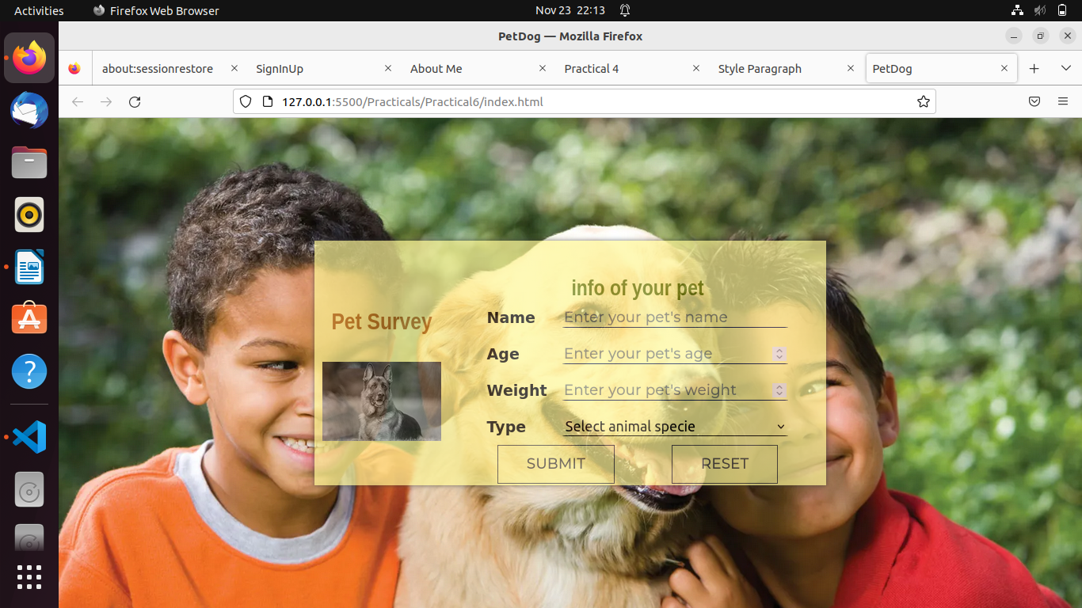

Practical 7:

html:

<!DOCTYPE html>

<html>

<head>

<meta charset="utf-8">

<title>Practical 7</title>

<style type="text/css">

#pet-data{

border: 1px solid black;

border-radius: 10px;

border-collapse: collapse;

}

td{

border: 1px solid black;

border-collapse: collapse;

}

#btn-fetch{

margin-top: 20px;

font-size: 24px;

font-weight: bold;

background-color: rgb(121, 109, 109);

color: white;

border-radius: 0px;

}

</style>

</head>

<body>

<div id="content">

</div>

<button id="btn-fetch">Fetch Data</button>

<script src="https://ajax.googleapis.com/ajax/libs/jquery/3.5.1/jquery.min.js"></script>

<script type="text/javascript">

var btnFetch = document.getElementById('btn-fetch');

var content = document.getElementById('content');

btnFetch.addEventListener('click', ()=>{

const xhr = new XMLHttpRequest();

xhr.open("GET",'./pet.json',true);

xhr.onload = ()=>{

console.log(xhr.responseText);

renderHtml(JSON.parse(xhr.responseText));

}

xhr.send();

});

function renderHtml(data){

content.innerHTML = "";

for (var i = 0; i <= data.length; i++) {

let p = document.createElement('p');

let htmlpart = "";

htmlpart += data[i].name+" is a "+data[i].type+" with age "+data[i].age+" years and weight "+data[i].weight+"kg and likes "+data[i].likes;

p.innerHTML = htmlpart;

content.append(p);

htmlpart="";

}

}

</script>

</body>

</html>

json:

[

{

"name":"Sheru",

"age":10,

"weight":12,

"type":"Pavellion",

"likes":"eating, playing with ball"

},

{

"name":"Binny",

"age":5,

"weight":24,

"type":"German Sefford",

"likes":"Biting, eating flesh"

},

{

"name":"Tom",

"age":5,

"weight":8,

"type":"cat",

"likes":"sleeping"

},

{

"name":"Jaggu",

"age":1,

"weight":1.5,

"type":"rabbit",

"likes":"running, eating cheese"

},

{

"name":"Chikulu",

"age":1,

"weight":1.2,

"type":"Hamster",

"likes":"running, eating carrot"

}

]

Output:

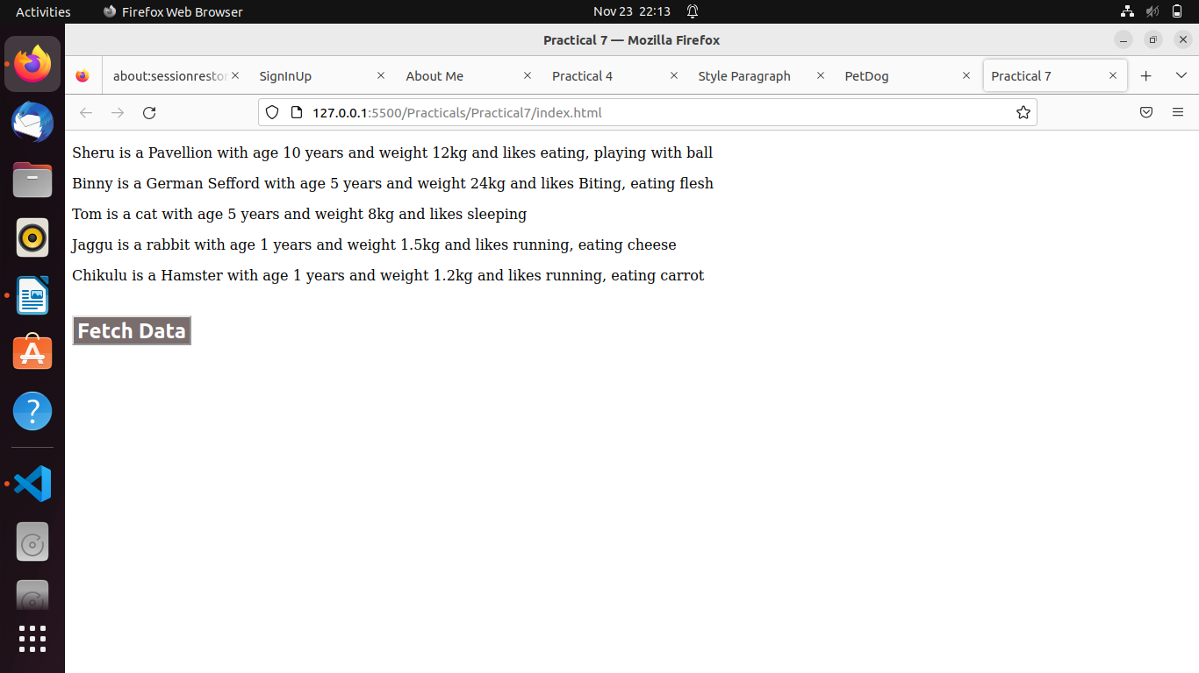

Practical 8:

html:

<!DOCTYPE html>

<html>

<head>

<meta charset="utf-8">

<title>Practical 8</title>

<link rel="stylesheet" href="style.css">

</head>

<body>

<div class="container">

<h1 class="heading">Bsc Hons Computer Science</h1>

<table class="info-table">

<tr class="table-row">

<td>Fee</td>

<td>33000</td>

</tr>

<tr class="table-row">

<td>Eligibility Criteria</td>

<td>12 Pass 96 percentage</td>

</tr>

<tr class="table-row">

<td>Subjects and credit scores</td>

<td class="table-data">

<table>

<tr class="table-row">

<th>Subject</th>

<th>Credit score</th>

</tr>

<tr class="table-row">

<td>IT</td>

<td>6</td>

</tr>

<tr class="table-row">

<td>Toc</td>

<td>6</td>

</tr>

<tr class="table-row">

<td>DAV</td>

<td>4</td>

</tr>

<tr class="table-row">

<td>DIP/Micro</td>

<td>4</td>

</tr>

</table>

</td>

</tr>

<tr>

<td>Future Opportunities</td>

<td>Bohot scope h isme par pata nahi kaha hai</td>

</tr>

</table>

</div>

<div id="btn-style">

<button class="btn-style">

Style Page

</button>

</div>

<script src="https://ajax.googleapis.com/ajax/libs/jquery/3.5.1/jquery.min.js"></script>

<script type="text/javascript">

$(document).ready(function () {

$('#btn-style').click(function () {

$("div").addClass('container');

$("table").addClass('info-table');

$("tr").addClass('table-row');

$("td").addClass('table-data');

$(".heading").css({

"textAlign": 'center'

});

});

});

</script>

</body>

</html>

css:

h1{

text-align: center;

padding: 15px;

}

.container {

width: 70%;

margin: auto;

align-items: center;

background-color: #b39160;

padding-bottom: 10px;

}

tbody{

margin: 13px;

}

.info-table {

width: 80%;

margin: auto;

border: 3px solid black;

background-color: #c7a679;

border-collapse: collapse;

margin-top: 2%;

margin-bottom: 2%;

border-radius: 10%;

}

.table-row {

width: 100%;

margin: auto;

padding: 5px;

}

.table-data {

width: 50%;

border: 2px solid white;

border-collapse: collapse;

background-color: blanchedalmond;

border-radius: 10%;

}

#btn-style{

text-align: center;

}

.btn-style{

margin: 10px;

padding: 15px;

background-color:#a89172;

border: solid rgb(197, 158, 178);

font-size: large;

}

Output:

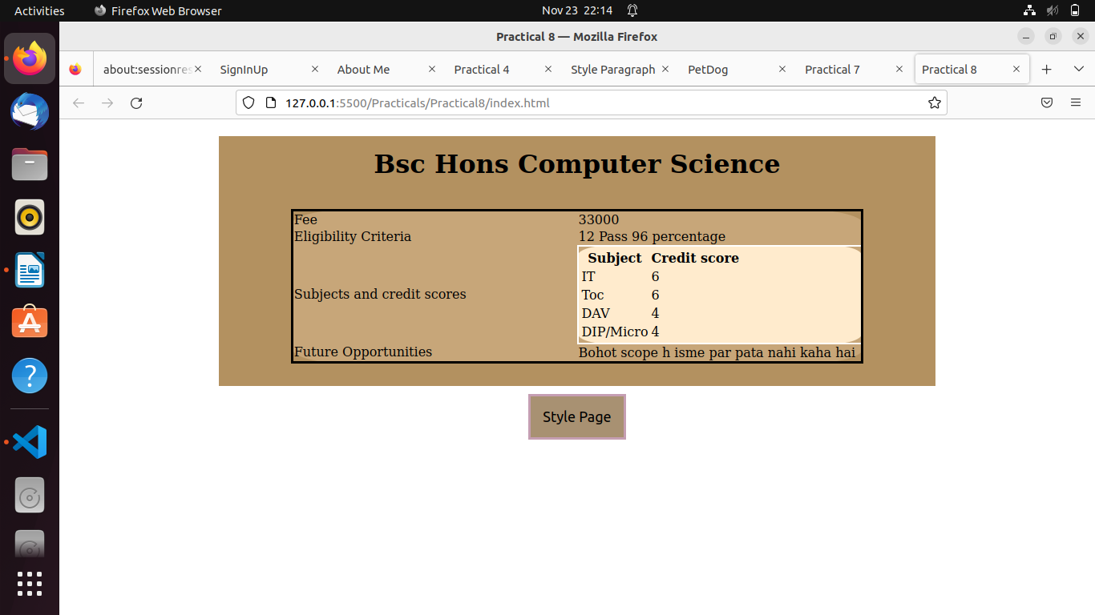

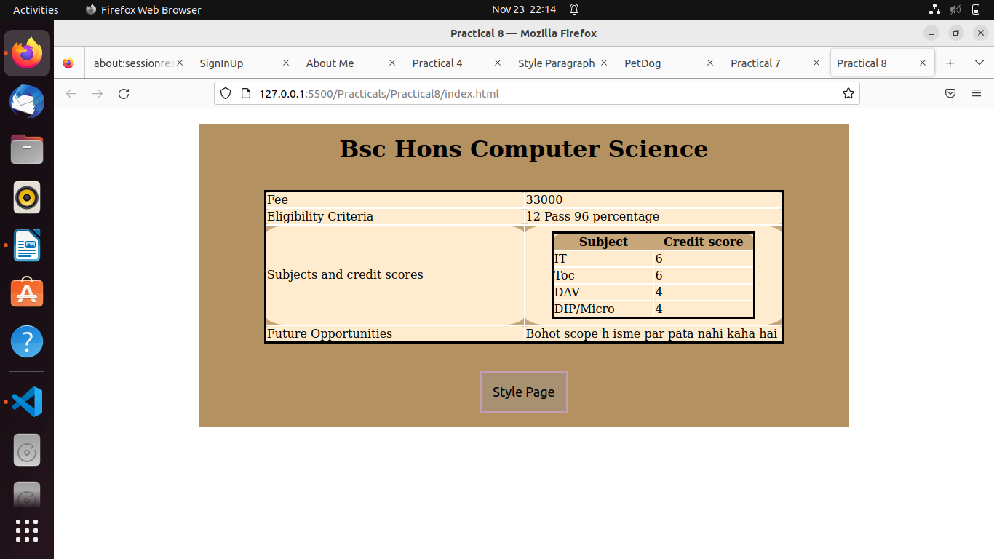

Practical 9:

html:

<!DOCTYPE html>

<html>

<head>

<meta charset="utf-8">

<meta name="viewport" content="width=device-width, initial-scale=1">

<link rel="stylesheet" href="https://maxcdn.bootstrapcdn.com/bootstrap/3.4.1/css/bootstrap.min.css">

<title>Practical 9</title>

<style type="text/css">

</style>

</head>

<body>

<div class="jumbotron text-center">

<h1>IMAGE GALLERY</h1>

<p>Responsive Image gallery using bootstrap.</p>

</div>

<div class="container">

<img class="col-sm-4" src="https://picsum.photos/200/"></img>

<img class="col-sm-4" src="https://picsum.photos/200/"></img>

<img class="col-sm-4" src="https://picsum.photos/200/"></img>

<img class="col-sm-4" src="https://picsum.photos/200/"></img>

<img class="col-sm-4" src="https://picsum.photos/200/"></img>

<img class="col-sm-4" src="https://picsum.photos/200/"></img>

</div>

<script src="https://ajax.googleapis.com/ajax/libs/jquery/3.5.1/jquery.min.js"></script>

<script src="https://maxcdn.bootstrapcdn.com/bootstrap/3.4.1/js/bootstrap.min.js"></script>

</body>

</html>

Output:

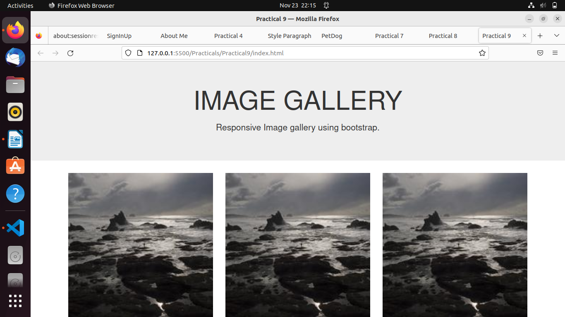

Practical 10:

Output:

Practical 11:

html:

<!DOCTYPE html>

<html lang="en">

<head>

<meta charset="UTF-8">

<meta http-equiv="X-UA-Compatible" content="IE=edge">

<meta name="viewport" content="width=device-width, initial-scale=1.0">

<title>SignInUp</title>

<link rel="stylesheet" href="style.css">

</head>

<body>

<main class="container" id="container">

<div class="form-container sign-up-container">

<form action="#">

<h1>Sign Up</h1>

<input type="text" placeholder="Name" />

<input type="email" placeholder="Email" />

<input type="password" placeholder="Password" />

<a href="#">You agree to T&C</a>

<button>Sign Up</button>

</form>

</div>

<div class="form-container sign-in-container">

<form action="#">

<h1>Sign in</h1>

<input type="email" placeholder="Email" />

<input type="password" placeholder="Password" />

<a href="#">Forgot your password?</a>

<button>Sign In</button>

</form>

</div>

<div class="overlay-container">

<div class="overlay">

<div class="overlay-panel overlay-left">

<h1>Already Have An Account?</h1>

<p>Sign in to access your dashboard</p>

<button class="ghost" id="signIn">Sign In</button>

</div>

<div class="overlay-panel overlay-right">

<h1>Hey There</h1>

<p>Create an account with us and get access to your dashboard</p>

<button class="ghost" id="signUp">Sign Up</button>

</div>

</div>

</div>

</div>

<script src="script.js"></script>

</body>

</html>

css:

@import url('https://fonts.googleapis.com/css?family=Montserrat:400,800');

* {

box-sizing: border-box;

}

body {

background: #f6f5f7;

display: flex;

justify-content: center;

align-items: center;

flex-direction: column;

font-family: 'Montserrat', sans-serif;

height: 100vh;

margin: 0;

padding: 0;

}

h1 {

font-weight: bold;

margin: 0;

}

h2 {

text-align: center;

}

p {

font-size: 14px;

font-weight: 100;

line-height: 20px;

letter-spacing: 0.5px;

margin: 20px 0 30px;

}

span {

font-size: 12px;

}

a {

color: rgb(206, 198, 198);

font-size: 14px;

text-decoration: none;

margin: 15px 0;

}

button {

border-radius: 20px;

border: 1px solid #09090c;

background-color: #0c0c11;

color: #ffffff;

font-size: 12px;

font-weight: bold;

padding: 12px 45px;

letter-spacing: 1px;

text-transform: uppercase;

transition: transform 80ms ease-in;

}

button:active {

transform: scale(0.95);

}

button:focus {

outline: none;

}

button.ghost {

background-color: transparent;

border-color: #ffffff;

}

form {

background-color: #ffffff;

background: linear-gradient(to right, #a965e9, #24272B);

display: flex;

align-items: center;

justify-content: center;

flex-direction: column;

padding: 0 50px;

height: 100%;

text-align: center;

}

form h1 {

margin-bottom: 0.33em;

}

input {

background-color: #eee;

border: none;

padding: 12px 15px;

margin: 8px 0;

width: 100%;

}

.container {

background-color: #fff;

box-shadow: 0 14px 28px rgba(0,0,0,0.22), 0 10px 10px rgba(0,0,0,0.22);

position: relative;

overflow: hidden;

width: 768px;

max-width: 100%;

min-height: 480px;

}

.form-container {

position: absolute;

top: 0;

height: 100%;

transition: all 0.6s ease-in-out;

}

.sign-in-container {

left: 0;

width: 50%;

z-index: 2;

}

.container.right-panel-active .sign-in-container {

transform: translateX(100%);

}

.sign-up-container {

left: 0;

width: 50%;

opacity: 0;

z-index: 1;

}

.container.right-panel-active .sign-up-container {

transform: translateX(100%);

opacity: 1;

z-index: 5;

animation: show 0.6s;

}

@keyframes show {

0%, 49.99% {

opacity: 0;

z-index: 1;

}

50%, 100% {

opacity: 1;

z-index: 5;

}

}

.overlay-container {

position: absolute;

top: 0;

left: 50%;

width: 50%;

height: 100%;

overflow: hidden;

transition: transform 0.6s ease-in-out;

z-index: 100;

}

.container.right-panel-active .overlay-container{

transform: translateX(-100%);

}

.overlay {

background: #6565e9;

background: linear-gradient(to right, #6565e9, #24272B);

background-repeat: no-repeat;

background-size: cover;

background-position: 0 0;

color: #ffffff;

position: relative;

left: -100%;

height: 100%;

width: 200%;

transform: translateX(0);

transition: transform 0.6s ease-in-out;

}

.container.right-panel-active .overlay {

transform: translateX(50%);

}

.overlay-panel {

position: absolute;

display: flex;

align-items: center;

justify-content: center;

flex-direction: column;

padding: 0 40px;

text-align: center;

top: 0;

height: 100%;

width: 50%;

transform: translateX(0);

transition: transform 0.6s ease-in-out;

}

.overlay-left {

transform: translateX(-20%);

}

.container.right-panel-active .overlay-left {

transform: translateX(0);

}

.overlay-right {

right: 0;

transform: translateX(0);

}

.container.right-panel-active .overlay-right {

transform: translateX(20%);

}

.social-container {

margin: 20px 0;

}

.social-container a {

border: 1px solid #DDDDDD;

border-radius: 50%;

display: inline-flex;

justify-content: center;

align-items: center;

margin: 0 5px;

height: 40px;

width: 40px;

}

footer {

background-color: #222;

color: #fff;

font-size: 14px;

bottom: 0;

position: fixed;

left: 0;

right: 0;

text-align: center;

z-index: 999;

}

footer p {

margin: 10px 0;

}

footer i {

color: red;

}

footer a {

color: #3c97bf;

text-decoration: none;

}

script:

const signUpButton = document.getElementById('signUp');

const signInButton = document.getElementById('signIn');

const container = document.getElementById('container');

signUpButton.addEventListener('click', () => {

container.classList.add("right-panel-active");

});

signInButton.addEventListener('click', () => {

container.classList.remove("right-panel-active");

});

Output:

